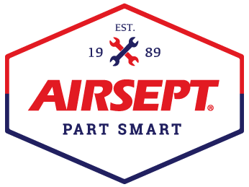

News Release

AirSept Introduces Emergency Kit for
Onsite Off-road Line Repair

Atlanta – August 29, 2023 – AirSept, recognized as the leader in developing innovative solutions for complex automotive repair problems, has now entered the off-road market with a convenient line repair kit that can be used to repair broken or damaged power steering, transmission, trans oil cooler, heater and engine oil cooler and A/C lines on-site.

The AirSept Broken Line Emergency Kit comes in a sturdy case and features the company’s award-winning Smart Splice™ connectors for metal line-to-metal line or metal line-to-hose repair without the need for special tools. Certified leak free up to 2,400 psi, the Smart Splice line repair system has been used by top technicians to make repairs in their shop to save time and money. Now experienced DIY’ers and off-road enthusiasts will have access to a condensed kit that can be used to make necessary repairs when a vehicle is hours from the closest garage.

AirSept’s Emergency Kit includes four metal line-to-metal line repair kits: (1) 5/16”, (1) 3/8”, (1) ½” and (1) 5/8” and four metal line to hose repair kits: (1) 5/16”, (1) 3/8”, (1) 1/2” and (1) 5/8”.

The eight Smart Splice repair solutions can be used to fix a line or hose leak or break in minutes. Designed to be especially durable in high vibration applications, the AirSept Broken Line Emergency Kit utilizes fittings that are OE approved and can be installed with a standard wrench.

AirSept President, Aaron Becker, says, “Our goal with this emergency kit is to make line repair easy and immediate so vehicles can be serviceable again. Living in Colorado, I have seen first-hand how difficult it is to deal with rough terrain. Anything can happen. This kit is lightweight and doesn’t take much space, so it is ideal to have at a campsite or event to keep your off-road vehicle operating when you are miles away from the closest shop.”

For more information on AirSept’s Broken Line Emergency Kit, visit www.airsept.com, visit AirSept at the 2023 SEMA Show in the Tools and Equipment Hall at booth #36237 or call toll free 800.999.1051. For more information about the Smart Splice line repair system, view this video. For the latest company and product news also connect on Facebook or YouTube.

# # # #

Image Attached: 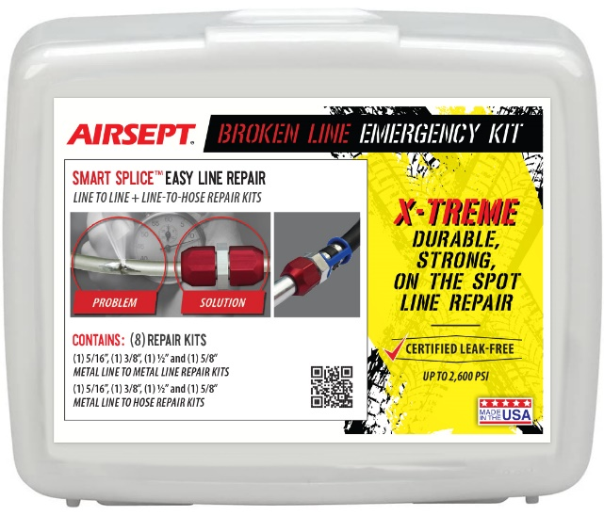

Caption: AirSept Broken Line Emergency Kit Designed for On-site Off-road Vehicle Repair

About AirSept
In 1989 AirSept created the first long-lasting solution to the problem of unwanted mold and mildew odor in automobile air conditioning systems. The product quickly became popular and in 1991 AirSept was incorporated as a company. AirSept began partnering with global OEMs and suppliers to not only market its Cooling Coil Coating, but to also develop other unique, new problem-solving products. From those humble beginnings, AirSept has grown to be the industry leader in the development of OEM and aftermarket solutions to complex automotive repair problems. AirSept products are designed to save time, money, and labor. For more information, visit www.AirSept.com.

For further product information, contact:
Aaron Becker, President
AirSept
678-973-2287
abecker@airsept.com

Leslie Allen
Owner
Wildcat Communications
615-429-7965
leslieallen.wildcat@gmail.com

